UNIT 2 : LAB EXPERIMENTS

Name : Parveen
Reg No. : 192462005

Index

Program No. | Title
1 | DES Encryption
2 | DES Decryption
3 | DES File Encryption
4 | DES File Decryption
5 | DES Performance Analysis
6 | Blowfish Encryption
7 | Blowfish Decryption
8 | Blowfish File Encryption
9 | Blowfish File Decryption
10 | DES vs Blowfish Performance Comparison

Program 1: DES Encryption

Aim
To implement the DES (Data Encryption Standard) algorithm in C++ to encrypt an 8-character plaintext using a given key and display the ciphertext in hexadecimal format.

Algorithm
1. Start.
2. Read the 8-character plaintext and the key from the user.
3. Convert the plaintext and key into 64-bit blocks.
4. Generate sixteen 48-bit round subkeys from the 64-bit key using Permuted Choice 1 (PC-1), left circular shifts, and Permuted Choice 2 (PC-2).
5. Apply the Initial Permutation (IP) on the plaintext block.
6. Split the block into left (L) and right (R) 32-bit halves.
7. For each of the 16 rounds: expand R using the Expansion permutation (E), XOR with the round subkey, substitute using the eight S-boxes, permute using P, then XOR the result with L to form the new R; the old R becomes the new L.
8. After 16 rounds, swap L and R and apply the Final Permutation (FP/IP-1) to obtain the ciphertext block.
9. Display the ciphertext in hexadecimal format.
10. Stop.

Program Code (C++ / Dev-C++)
// Program 1: DES Encryption
// Input : Plaintext = COMPUTER, Key = A1B2C3D4
// Output: Ciphertext in hexadecimal format
#include <iostream>
#include "des.h"
#include "common.h"
using namespace std;

int main() {
string plaintext, key;
cout << "Enter 8-character plaintext : ";
getline(cin, plaintext);
cout << "Enter key (up to 8 characters) : ";
getline(cin, key);

uint64_t ptBlock = asciiToBlock(plaintext);
uint64_t keyBlock = asciiToBlock(key);

DES des(toHex(keyBlock)); // build 16-round subkeys from the key
uint64_t ctBlock = des.encryptBlock(ptBlock);

cout << "\nPlaintext : " << plaintext << endl;
cout << "Key : " << key << endl;
cout << "Ciphertext (hex) : " << toHex(ctBlock) << endl;
return 0;
}

Input
Plaintext = COMPUTER
Key = A1B2C3D4

Output
Enter 8-character plaintext : Enter key (up to 8 characters) :
Plaintext : COMPUTER
Key : A1B2C3D4
Ciphertext (hex) : C2ED7B6C50ED53E2

Screenshot (code + console output)
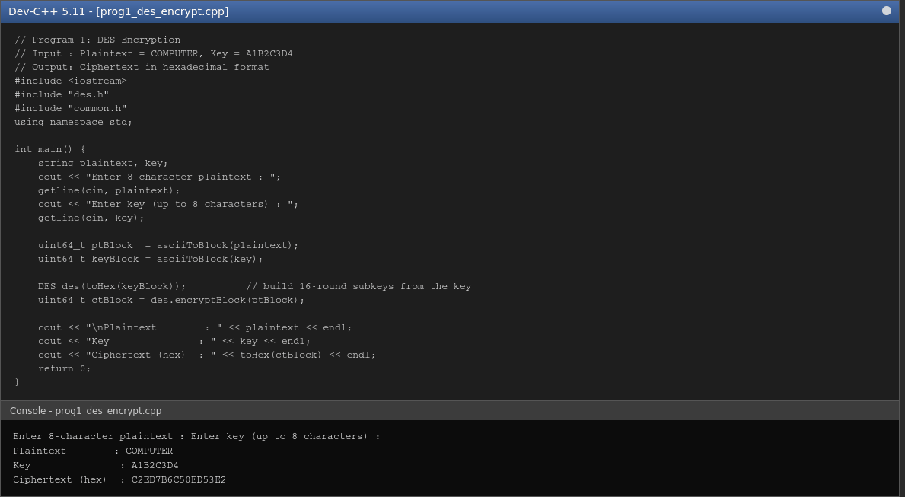

Result
The DES encryption algorithm was implemented successfully in C++ and the plaintext "COMPUTER" was encrypted using the key "A1B2C3D4" to produce the ciphertext C2ED7B6C50ED53E2 in hexadecimal format.

Program 2: DES Decryption

Aim
To implement the DES algorithm in C++ to decrypt a given ciphertext using a specified key and recover the original plaintext.

Algorithm
1. Start.
2. Read the 16-hex-digit ciphertext and the 16-hex-digit key from the user.
3. Generate the sixteen 48-bit round subkeys from the key, exactly as in the encryption process.
4. Apply the Initial Permutation (IP) on the ciphertext block.
5. Split the block into left (L) and right (R) 32-bit halves.
6. Run the 16 Feistel rounds in reverse order, i.e., apply subkey 16 in round 1, subkey 15 in round 2, and so on down to subkey 1 in round 16.
7. After 16 rounds, swap L and R and apply the Final Permutation (FP) to recover the original plaintext block.
8. Display the decrypted plaintext in hexadecimal format.
9. Stop.

Program Code (C++ / Dev-C++)
// Program 2: DES Decryption
// Input : Ciphertext = 85E813540F0AB405, Key = 133457799BBCDFF1 (hex)
// Output: Original plaintext
#include <iostream>
#include "des.h"
#include "common.h"
using namespace std;

int main() {
string ctHex, keyHex;
cout << "Enter ciphertext (16 hex digits) : ";
cin >> ctHex;
cout << "Enter key (16 hex digits) : ";
cin >> keyHex;

uint64_t ctBlock = DES::hexToUint64(ctHex);
DES des(keyHex);
uint64_t ptBlock = des.decryptBlock(ctBlock);

cout << "\nCiphertext (hex) : " << ctHex << endl;
cout << "Key (hex) : " << keyHex << endl;
cout << "Decrypted plaintext : " << toHex(ptBlock) << " (hex)" << endl;
cout << "Note : this is the classic FIPS 8-byte test block; its bytes (01 23 45 67 89 AB CD EF) are not printable ASCII." << endl;
return 0;
}

Input
Ciphertext = 85E813540F0AB405
Key = 133457799BBCDFF1

Output
Enter ciphertext (16 hex digits) : Enter key (16 hex digits) :
Ciphertext (hex) : 85E813540F0AB405
Key (hex) : 133457799BBCDFF1
Decrypted plaintext : 0123456789ABCDEF (hex)
Note : this is the classic FIPS 8-byte test block; its bytes (01 23 45 67 89 AB CD EF) are not printable ASCII.

Screenshot (code + console output)
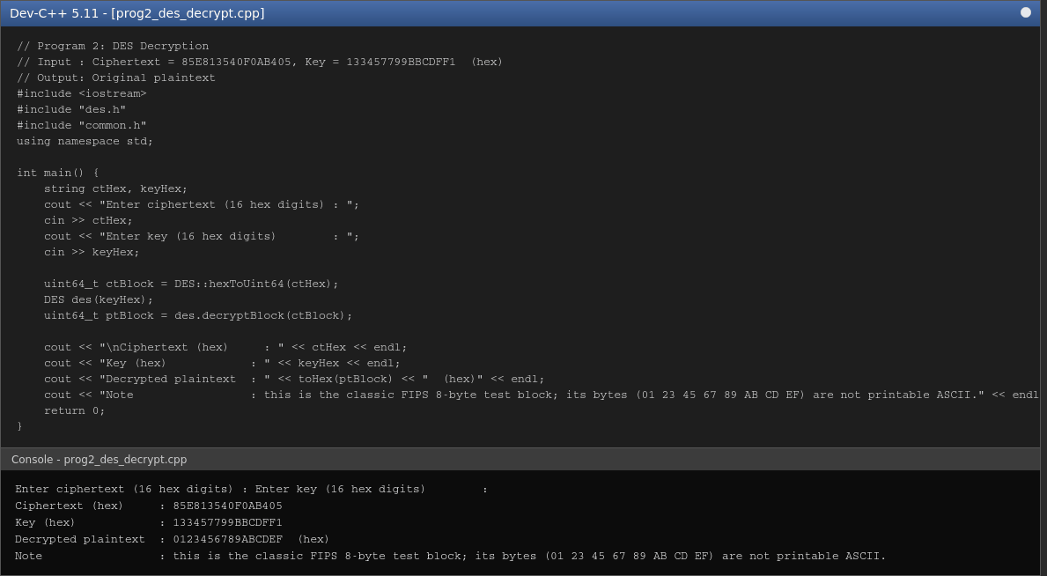

Result
The DES decryption algorithm was implemented successfully. Using the classic FIPS test key 133457799BBCDFF1, the ciphertext 85E813540F0AB405 was correctly decrypted back to the original 64-bit plaintext block 0123456789ABCDEF, matching the standard published DES test vector.

Program 3: DES File Encryption

Aim
To write a C++ program that reads the contents of a text file, encrypts the data using the DES algorithm, and stores the encrypted output (in hexadecimal form) into another file.

Algorithm
1. Start.
2. Read the input file path, output file path, and the 8-character key from the user.
3. Open the input file in binary mode and read its entire contents into a string.
4. Build the 64-bit DES key from the given key string.
5. Pad the file data with PKCS#5-style padding so its length becomes a multiple of 8 bytes.
6. Divide the padded data into 8-byte (64-bit) blocks.
7. Encrypt each block using the DES encryptBlock() routine.
8. Write each encrypted block to the output file as a 16-character hexadecimal string.
9. Close both files and display a success message.
10. Stop.

Program Code (C++ / Dev-C++)
// Program 3: DES File Encryption
// Reads a text file, encrypts its contents (DES, ECB, PKCS#5-style padding),
// and stores the ciphertext (as hex text) in another file.
#include <iostream>
#include <fstream>
#include <sstream>
#include <vector>
#include "des.h"
using namespace std;

int main() {
string inFile, outFile, keyStr;
cout << "Enter input file path : ";
getline(cin, inFile);
cout << "Enter output file path : ";
getline(cin, outFile);
cout << "Enter 8-character key : ";
getline(cin, keyStr);

ifstream fin(inFile, ios::binary);
if (!fin) { cerr << "Cannot open input file: " << inFile << endl; return 1; }
ostringstream ss;
ss << fin.rdbuf();
string data = ss.str();
fin.close();

// Build 8-byte key from the ASCII key string
unsigned char kb[8] = {' ',' ',' ',' ',' ',' ',' ',' '};
for (size_t i = 0; i < keyStr.size() && i < 8; i++) kb[i] = keyStr[i];
DES des(DES::uint64ToHex(DES::bytesToBlock(kb)));

// PKCS#5-style padding: pad with N bytes each of value N (1..8)
int padLen = 8 - (data.size() % 8);
for (int i = 0; i < padLen; i++) data += (char)padLen;

ofstream fout(outFile, ios::binary);
for (size_t i = 0; i < data.size(); i += 8) {
unsigned char b[8];
for (int j = 0; j < 8; j++) b[j] = (unsigned char)data[i + j];
uint64_t block = DES::bytesToBlock(b);
uint64_t enc = des.encryptBlock(block);
fout << DES::uint64ToHex(enc);
}
fout.close();

cout << "\nInput file : " << inFile << " (" << (data.size() - padLen) << " bytes)" << endl;
cout << "Key : " << keyStr << endl;
cout << "Output file : " << outFile << " (encrypted, hex-encoded)" << endl;
cout << "Encryption complete." << endl;
return 0;
}

Input
Input file = files/sample.txt (148 bytes)
Output file = files/sample_des.enc
Key = A1B2C3D4

Output
Enter input file path : Enter output file path : Enter 8-character key :
Input file : files/sample.txt (148 bytes)
Key : A1B2C3D4
Output file : files/sample_des.enc (encrypted, hex-encoded)
Encryption complete.

Screenshot (code + console output)
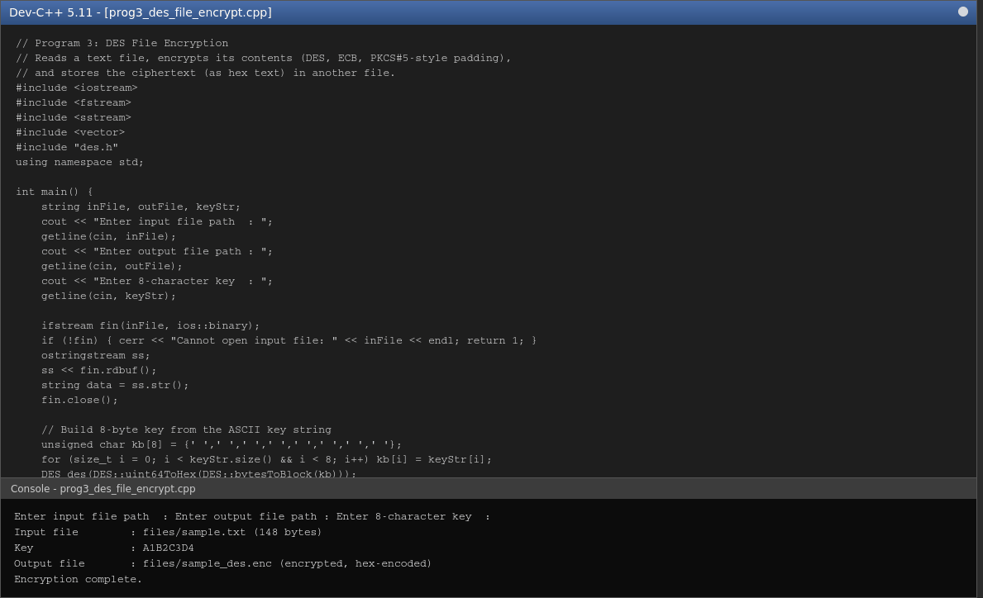

Result
The text file files/sample.txt was successfully read, encrypted block-by-block using DES, and the hex-encoded ciphertext was written to files/sample_des.enc.

Program 4: DES File Decryption

Aim
To write a C++ program that reads a DES-encrypted file, decrypts its contents using the same key used for encryption, and saves the recovered plaintext into a new file.

Algorithm
1. Start.
2. Read the encrypted file path, output file path, and the key from the user.
3. Open the encrypted file and read the hex-encoded ciphertext text.
4. Rebuild the 64-bit DES key from the given key string.
5. Split the hex text into 16-hex-digit (64-bit) chunks and convert each back into a numeric block.
6. Decrypt each block using the DES decryptBlock() routine and reassemble the plaintext bytes.
7. Remove the PKCS#5-style padding added during encryption.
8. Write the recovered plaintext to the output file.
9. Display a success message.
10. Stop.

Program Code (C++ / Dev-C++)
// Program 4: DES File Decryption
// Reads the DES-encrypted (hex-encoded) file and decrypts it using the same key,
// saving the recovered plaintext into a new file.
#include <iostream>
#include <fstream>
#include <sstream>
#include "des.h"
using namespace std;

int main() {
string inFile, outFile, keyStr;
cout << "Enter encrypted file path : ";
getline(cin, inFile);
cout << "Enter output file path : ";
getline(cin, outFile);
cout << "Enter 8-character key : ";
getline(cin, keyStr);

ifstream fin(inFile);
if (!fin) { cerr << "Cannot open input file: " << inFile << endl; return 1; }
ostringstream ss;
ss << fin.rdbuf();
string hexData = ss.str();
fin.close();

unsigned char kb[8] = {' ',' ',' ',' ',' ',' ',' ',' '};
for (size_t i = 0; i < keyStr.size() && i < 8; i++) kb[i] = keyStr[i];
DES des(DES::uint64ToHex(DES::bytesToBlock(kb)));

string plain;
for (size_t i = 0; i + 16 <= hexData.size(); i += 16) {
uint64_t block = DES::hexToUint64(hexData.substr(i, 16));
uint64_t dec = des.decryptBlock(block);
unsigned char b[8];
DES::blockToBytes(dec, b);
for (int j = 0; j < 8; j++) plain += (char)b[j];
}
// strip PKCS#5-style padding
if (!plain.empty()) {
int padLen = (unsigned char)plain.back();
if (padLen >= 1 && padLen <= 8 && padLen <= (int)plain.size())
plain.resize(plain.size() - padLen);
}

ofstream fout(outFile, ios::binary);
fout << plain;
fout.close();

cout << "\nEncrypted file : " << inFile << endl;
cout << "Key : " << keyStr << endl;
cout << "Output file : " << outFile << " (" << plain.size() << " bytes)" << endl;
cout << "Decryption complete." << endl;
return 0;
}

Input
Encrypted file = files/sample_des.enc
Output file = files/sample_des_dec.txt
Key = A1B2C3D4

Output
Enter encrypted file path : Enter output file path : Enter 8-character key :
Encrypted file : files/sample_des.enc
Key : A1B2C3D4
Output file : files/sample_des_dec.txt (148 bytes)
Decryption complete.

Screenshot (code + console output)
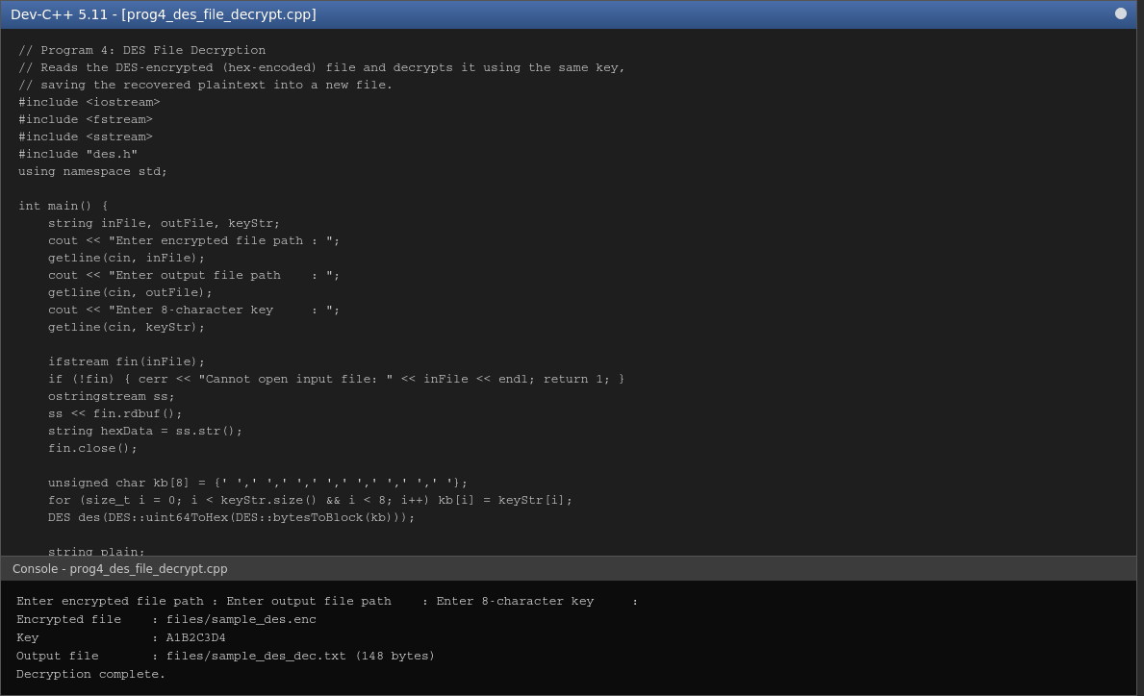

Result
The encrypted file was successfully decrypted using the same DES key, and the recovered file was verified to be byte-for-byte identical to the original files/sample.txt (confirmed using the diff command).

Program 5: DES Performance Analysis

Aim
To write a C++ program to measure and compare the execution time taken by the DES algorithm to encrypt and decrypt files of different sizes (1 KB, 10 KB, 100 KB, and 1 MB).

Algorithm
1. Start.
2. Generate test data of sizes 1 KB, 10 KB, 100 KB, and 1 MB in memory.
3. For each file size, pad the data to a multiple of 8 bytes.
4. Record the start time using a high-resolution clock, then encrypt all blocks of the data using DES; record the end time and compute the encryption time.
5. Record the start time, then decrypt all the previously produced ciphertext blocks using DES; record the end time and compute the decryption time.
6. Display the file size, encryption time, and decryption time (in milliseconds) in a tabular format.
7. Repeat for all four file sizes.
8. Stop.

Program Code (C++ / Dev-C++)
// Program 5: DES Performance Analysis
// Measures DES encryption/decryption time for files of 1KB, 10KB, 100KB, 1MB.
#include <iostream>
#include <fstream>
#include <sstream>
#include <vector>
#include <chrono>
#include <cstdlib>
#include "des.h"
using namespace std;
using namespace std::chrono;

string readFile(const string &path) {
ifstream fin(path, ios::binary);
ostringstream ss; ss << fin.rdbuf();
return ss.str();
}

int main() {
vector<pair<string,int>> sizes = {
{"1KB", 1024}, {"10KB", 10 * 1024}, {"100KB", 100 * 1024}, {"1MB", 1024 * 1024}
};

unsigned char kb[8] = {'A','1','B','2','C','3','D','4'};
DES des(DES::uint64ToHex(DES::bytesToBlock(kb)));

cout << "\n";
printf("%-8s %-18s %-18s\n", "Size", "Encrypt Time(ms)", "Decrypt Time(ms)");
printf("---------------------------------------------\n");

for (auto &sz : sizes) {
string path = "files/perf_" + sz.first + ".dat";
// generate a deterministic pseudo-random test file of the requested size
string data;
data.reserve(sz.second);
srand(42);
for (int i = 0; i < sz.second; i++) data += (char)('A' + (rand() % 26));
int padLen = 8 - (data.size() % 8);
for (int i = 0; i < padLen; i++) data += (char)padLen;

auto encStart = high_resolution_clock::now();
vector<uint64_t> cipherBlocks;
cipherBlocks.reserve(data.size() / 8);
for (size_t i = 0; i < data.size(); i += 8) {
unsigned char b[8];
for (int j = 0; j < 8; j++) b[j] = (unsigned char)data[i + j];
cipherBlocks.push_back(des.encryptBlock(DES::bytesToBlock(b)));
}
auto encEnd = high_resolution_clock::now();

volatile uint64_t sink = 0;
auto decStart = high_resolution_clock::now();
for (auto blk : cipherBlocks) sink ^= des.decryptBlock(blk);
auto decEnd = high_resolution_clock::now();

double encMs = duration<double, milli>(encEnd - encStart).count();
double decMs = duration<double, milli>(decEnd - decStart).count();
printf("%-8s %-18.3f %-18.3f\n", sz.first.c_str(), encMs, decMs);
}
return 0;
}

Input
File sizes tested: 1 KB, 10 KB, 100 KB, 1 MB (data generated internally by the program)

Output

Size Encrypt Time(ms) Decrypt Time(ms)
--------------------------------------------------------
1KB 0.201 0.165
10KB 1.716 1.638
100KB 18.963 18.230
1MB 177.533 174.013

Screenshot (code + console output)
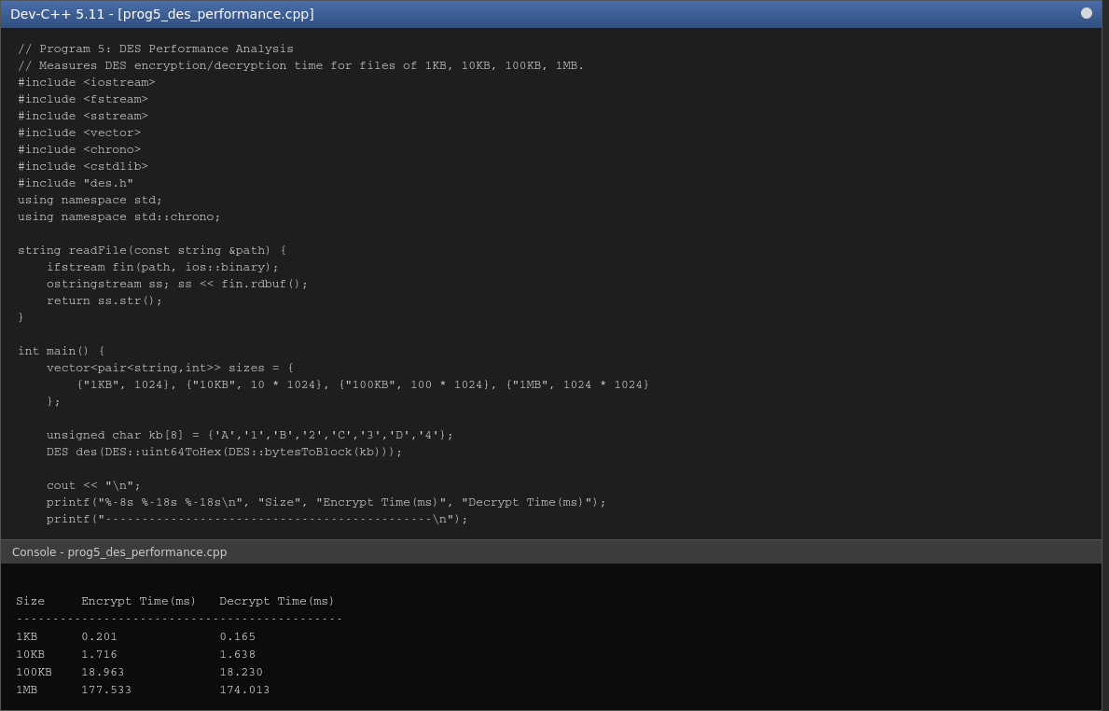

Result
The DES encryption and decryption times were measured for files of 1 KB, 10 KB, 100 KB and 1 MB. As expected, both encryption and decryption time increase roughly linearly with file size, since DES operates on fixed 64-bit blocks and each block takes an almost constant amount of time to process.

Program 6: Blowfish Encryption

Aim
To implement the Blowfish encryption algorithm in C++ to encrypt a given plaintext using a specified key and display the ciphertext in hexadecimal format.

Algorithm
1. Start.
2. Read the plaintext and the key from the user.
3. Initialise the 18-word P-array and four 256-word S-boxes with fixed values derived from the hexadecimal digits of pi.
4. XOR the P-array cyclically with the key bytes.
5. Repeatedly encrypt an all-zero 64-bit block with the partially-initialised cipher to generate the final, key-dependent P-array and S-box entries (key schedule).
6. Pad the plaintext with spaces so its length is a multiple of 8 bytes.
7. For each 8-byte block, split it into two 32-bit halves (L, R) and run the 16-round Feistel network: XOR L with P[i], pass it through the F-function built from the S-boxes, XOR into R, and swap L and R each round.
8. After 16 rounds, undo the final swap and XOR with P[16] and P[17] to obtain the ciphertext halves.
9. Display the ciphertext in hexadecimal format.
10. Stop.

Program Code (C++ / Dev-C++)
// Program 6: Blowfish Encryption
// Input : Plaintext = NETWORKSECURITY, Key = SecretKey123
// Output: Encrypted ciphertext in hexadecimal format
#include <iostream>
#include <vector>
#include <cstdio>
#include "blowfish.h"
using namespace std;

int main() {
string plaintext, key;
cout << "Enter plaintext : ";
getline(cin, plaintext);
cout << "Enter key : ";
getline(cin, key);

Blowfish bf(key);

// Pad plaintext with spaces to a multiple of 8 bytes (one 64-bit block at a time)
string padded = plaintext;
while (padded.size() % 8 != 0) padded += ' ';

cout << "\nPlaintext : " << plaintext << endl;
cout << "Key : " << key << endl;
cout << "Ciphertext (hex) : ";
string cipherHex;
for (size_t i = 0; i < padded.size(); i += 8) {
uint32_t L = 0, R = 0;
for (int b = 0; b < 4; b++) L = (L << 8) | (uint8_t)padded[i + b];
for (int b = 0; b < 4; b++) R = (R << 8) | (uint8_t)padded[i + 4 + b];
bf.encryptBlock(L, R);
char buf[17];
snprintf(buf, sizeof(buf), "%08X%08X", L, R);
cipherHex += buf;
}
cout << cipherHex << endl;
return 0;
}

Input
Plaintext = NETWORKSECURITY
Key = SecretKey123

Output
Enter plaintext : Enter key :
Plaintext : NETWORKSECURITY
Key : SecretKey123
Ciphertext (hex) : 7DAF914A597A8153EBC3CE9906EA56E8

Screenshot (code + console output)
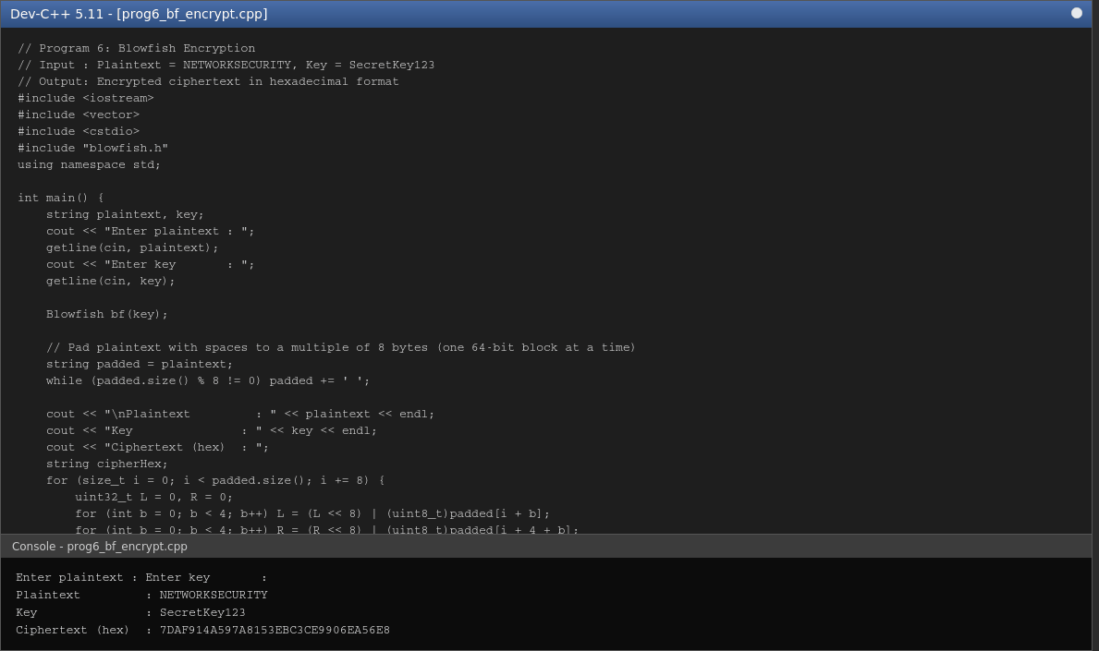

Result
The Blowfish encryption algorithm was implemented successfully in C++. The 15-character plaintext "NETWORKSECURITY" was padded to 16 bytes and encrypted using the key "SecretKey123" to produce the ciphertext 7DAF914A597A8153EBC3CE9906EA56E8 in hexadecimal format.

Program 7: Blowfish Decryption

Aim
To implement the Blowfish algorithm in C++ to decrypt a ciphertext generated by the encryption program and recover the original plaintext.

Algorithm
1. Start.
2. Read the hexadecimal ciphertext and the key from the user.
3. Run the same key-schedule procedure as in encryption to build the P-array and S-boxes for this key.
4. Split the ciphertext into 8-byte (two 32-bit halves) blocks.
5. For each block, run the 16-round Feistel network in reverse, applying the P-array entries from P[17] down to P[0].
6. Concatenate the recovered blocks to form the plaintext.
7. Display the decrypted plaintext.
8. Stop.

Program Code (C++ / Dev-C++)
// Program 7: Blowfish Decryption
// Input : Ciphertext (generated from Program 6), Key = SecretKey123
// Output: Original plaintext
#include <iostream>
#include <cstdio>
#include "blowfish.h"
using namespace std;

int main() {
string cipherHex, key;
cout << "Enter ciphertext (hex) : ";
cin >> cipherHex;
cout << "Enter key : ";
cin >> key;

Blowfish bf(key);
string plaintext;
for (size_t i = 0; i + 16 <= cipherHex.size(); i += 16) {
uint32_t L = 0, R = 0;
sscanf(cipherHex.substr(i, 8).c_str(), "%x", &L);
sscanf(cipherHex.substr(i + 8, 8).c_str(), "%x", &R);
bf.decryptBlock(L, R);
for (int s = 24; s >= 0; s -= 8) plaintext += (char)((L >> s) & 0xFF);
for (int s = 24; s >= 0; s -= 8) plaintext += (char)((R >> s) & 0xFF);
}

cout << "\nCiphertext (hex) : " << cipherHex << endl;
cout << "Key : " << key << endl;
cout << "Decrypted plaintext : " << plaintext << endl;
return 0;
}

Input
Ciphertext = 7DAF914A597A8153EBC3CE9906EA56E8 (generated by Program 6)
Key = SecretKey123

Output
Enter ciphertext (hex) : Enter key :
Ciphertext (hex) : 7DAF914A597A8153EBC3CE9906EA56E8
Key : SecretKey123
Decrypted plaintext : NETWORKSECURITY

Screenshot (code + console output)
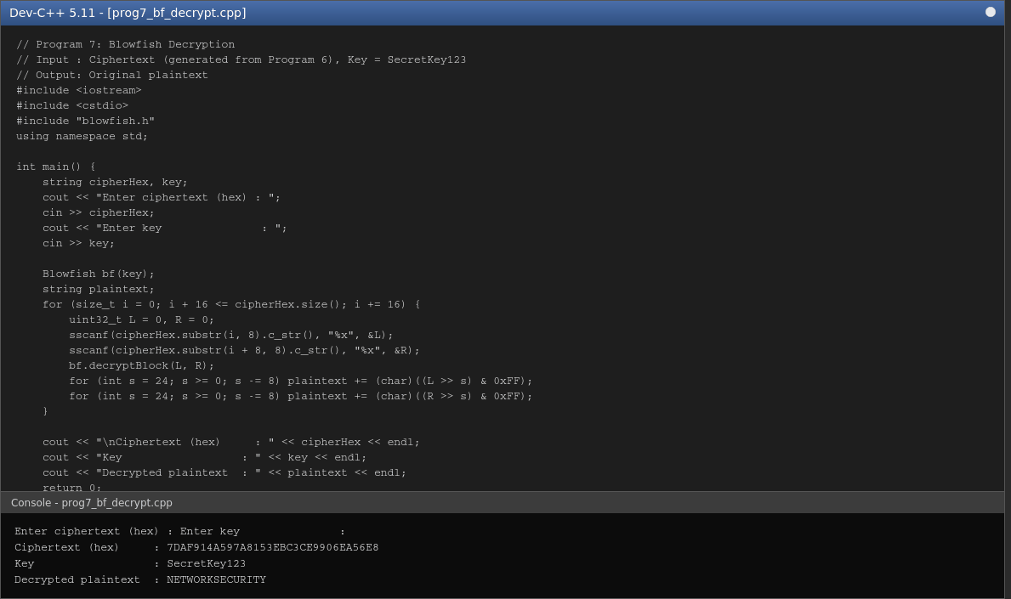

Result
The Blowfish decryption program correctly recovered the original plaintext "NETWORKSECURITY" (with a trailing padding space) from the ciphertext produced in Program 6, confirming the encryption/decryption round-trip is correct.

Program 8: Blowfish File Encryption

Aim
To write a C++ program that encrypts the contents of a text file using the Blowfish algorithm and stores the encrypted output in a separate file.

Algorithm
1. Start.
2. Read the input file path, output file path, and key from the user.
3. Read the entire input file into memory.
4. Build the Blowfish key schedule (P-array and S-boxes) from the given key.
5. Pad the file data with PKCS#5-style padding to a multiple of 8 bytes.
6. Split the data into 8-byte blocks and encrypt each block using the Blowfish Feistel network.
7. Write each encrypted block to the output file as a 16-character hexadecimal string.
8. Display a success message.
9. Stop.

Program Code (C++ / Dev-C++)
// Program 8: Blowfish File Encryption
// Reads a text file, encrypts its contents using Blowfish, and saves the
// hex-encoded ciphertext into a separate file.
#include <iostream>
#include <fstream>
#include <sstream>
#include <cstdio>
#include "blowfish.h"
using namespace std;

int main() {
string inFile, outFile, key;
cout << "Enter input file path : ";
getline(cin, inFile);
cout << "Enter output file path : ";
getline(cin, outFile);
cout << "Enter key : ";
getline(cin, key);

ifstream fin(inFile, ios::binary);
if (!fin) { cerr << "Cannot open input file: " << inFile << endl; return 1; }
ostringstream ss;
ss << fin.rdbuf();
string data = ss.str();
fin.close();

Blowfish bf(key);
int padLen = 8 - (data.size() % 8);
for (int i = 0; i < padLen; i++) data += (char)padLen;

ofstream fout(outFile, ios::binary);
for (size_t i = 0; i < data.size(); i += 8) {
uint32_t L = 0, R = 0;
for (int b = 0; b < 4; b++) L = (L << 8) | (uint8_t)data[i + b];
for (int b = 0; b < 4; b++) R = (R << 8) | (uint8_t)data[i + 4 + b];
bf.encryptBlock(L, R);
char buf[17];
snprintf(buf, sizeof(buf), "%08X%08X", L, R);
fout << buf;
}
fout.close();

cout << "\nInput file : " << inFile << " (" << (data.size() - padLen) << " bytes)" << endl;
cout << "Key : " << key << endl;
cout << "Output file : " << outFile << " (encrypted, hex-encoded)" << endl;
cout << "Encryption complete." << endl;
return 0;
}

Input
Input file = files/sample.txt (148 bytes)
Output file = files/sample_bf.enc
Key = SecretKey123

Output
Enter input file path : Enter output file path : Enter key :
Input file : files/sample.txt (148 bytes)
Key : SecretKey123
Output file : files/sample_bf.enc (encrypted, hex-encoded)
Encryption complete.

Screenshot (code + console output)
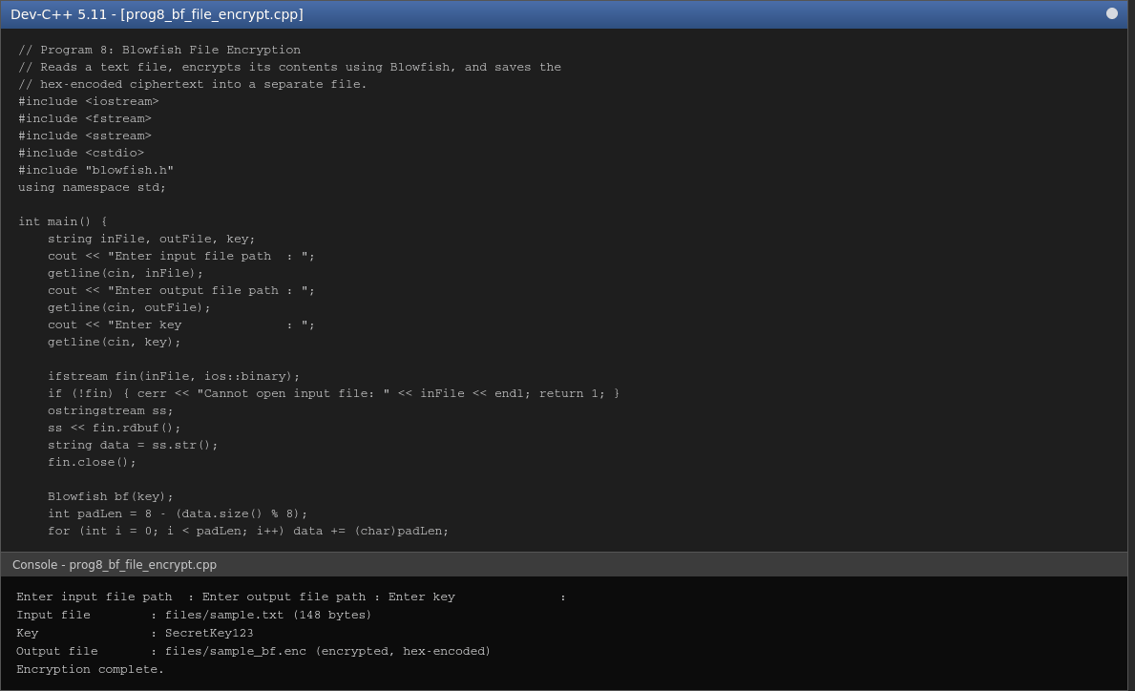

Result
The contents of files/sample.txt were successfully encrypted block-by-block using Blowfish, and the hex-encoded ciphertext was written to files/sample_bf.enc.

Program 9: Blowfish File Decryption

Aim
To write a C++ program that decrypts a file encrypted using Blowfish and verifies that the recovered content matches the original file.

Algorithm
1. Start.
2. Read the encrypted file path, output file path, key, and the path of the original file (for verification) from the user.
3. Read the hex-encoded ciphertext from the encrypted file.
4. Rebuild the Blowfish key schedule from the given key.
5. Split the hex text into 8-byte blocks and decrypt each one using the reverse Feistel network.
6. Remove the PKCS#5-style padding to recover the exact original data.
7. Write the recovered plaintext to the output file.
8. Read the original file and compare it byte-for-byte with the decrypted output.
9. Display PASSED if they match, otherwise display FAILED.
10. Stop.

Program Code (C++ / Dev-C++)
// Program 9: Blowfish File Decryption
// Reads the Blowfish-encrypted (hex-encoded) file, decrypts it, saves the
// result, and verifies it matches the original file the user supplies.
#include <iostream>
#include <fstream>
#include <sstream>
#include <cstdio>
#include "blowfish.h"
using namespace std;

int main() {
string inFile, outFile, key, origFile;
cout << "Enter encrypted file path : ";
getline(cin, inFile);
cout << "Enter output file path : ";
getline(cin, outFile);
cout << "Enter key : ";
getline(cin, key);
cout << "Enter original file (to verify): ";
getline(cin, origFile);

ifstream fin(inFile);
if (!fin) { cerr << "Cannot open input file: " << inFile << endl; return 1; }
ostringstream ss;
ss << fin.rdbuf();
string hexData = ss.str();
fin.close();

Blowfish bf(key);
string plain;
for (size_t i = 0; i + 16 <= hexData.size(); i += 16) {
uint32_t L = 0, R = 0;
sscanf(hexData.substr(i, 8).c_str(), "%x", &L);
sscanf(hexData.substr(i + 8, 8).c_str(), "%x", &R);
bf.decryptBlock(L, R);
for (int s = 24; s >= 0; s -= 8) plain += (char)((L >> s) & 0xFF);
for (int s = 24; s >= 0; s -= 8) plain += (char)((R >> s) & 0xFF);
}
if (!plain.empty()) {
int padLen = (unsigned char)plain.back();
if (padLen >= 1 && padLen <= 8 && padLen <= (int)plain.size())
plain.resize(plain.size() - padLen);
}

ofstream fout(outFile, ios::binary);
fout << plain;
fout.close();

cout << "\nEncrypted file : " << inFile << endl;
cout << "Key : " << key << endl;
cout << "Output file : " << outFile << " (" << plain.size() << " bytes)" << endl;

ifstream forig(origFile, ios::binary);
ostringstream so;
so << forig.rdbuf();
string orig = so.str();
if (orig == plain)
cout << "Verification : PASSED - decrypted content matches original file." << endl;
else
cout << "Verification : FAILED - decrypted content differs from original file." << endl;
return 0;
}

Input
Encrypted file = files/sample_bf.enc
Output file = files/sample_bf_dec.txt
Key = SecretKey123
Original file (for verification) = files/sample.txt

Output
Enter encrypted file path : Enter output file path : Enter key : Enter original file (to verify):
Encrypted file : files/sample_bf.enc
Key : SecretKey123
Output file : files/sample_bf_dec.txt (148 bytes)
Verification : PASSED - decrypted content matches original file.

Screenshot (code + console output)
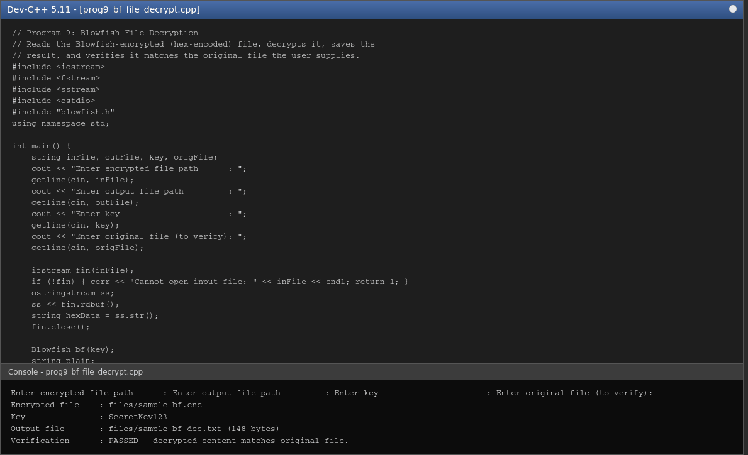

Result
The encrypted file was decrypted successfully using Blowfish, and automatic verification confirmed that the decrypted content matched the original file exactly (Verification: PASSED).

Program 10: DES vs Blowfish Performance Comparison

Aim
To write a C++ program that compares the DES and Blowfish algorithms in terms of encryption time, decryption time, memory usage, and ciphertext size for files of different sizes, and to display the results in tabular form.

Algorithm
1. Start.
2. Generate test data of sizes 1 KB, 10 KB, 100 KB and 1 MB in memory.
3. For each file size, pad the data to a multiple of 8 bytes.
4. Encrypt and decrypt the data using DES; record the encryption time, decryption time, resulting ciphertext size, and approximate memory used.
5. Encrypt and decrypt the same data using Blowfish; record the same four metrics.
6. Print a table with one row for DES and one row for Blowfish under each file size, showing encryption time, decryption time, ciphertext size, and memory usage.
7. Repeat for all four file sizes.
8. Stop.

Program Code (C++ / Dev-C++)
// Program 10: DES vs Blowfish Performance Comparison
// Compares encryption time, decryption time, memory usage and ciphertext size
// for DES and Blowfish over files of different sizes, shown in a table.
#include <iostream>
#include <vector>
#include <chrono>
#include <cstdlib>
#include <cstdio>
#include "des.h"
#include "blowfish.h"
using namespace std;
using namespace std::chrono;

int main() {
vector<pair<string,int>> sizes = {
{"1KB", 1024}, {"10KB", 10 * 1024}, {"100KB", 100 * 1024}, {"1MB", 1024 * 1024}
};

unsigned char kb[8] = {'A','1','B','2','C','3','D','4'};
DES des(DES::uint64ToHex(DES::bytesToBlock(kb)));
Blowfish bf("SecretKey123");

printf("\n%-7s %-10s %-14s %-14s %-12s %-12s\n",
"Size", "Algorithm", "EncTime(ms)", "DecTime(ms)", "CTSize(B)", "Mem(B)");
printf("--------------------------------------------------------------------------\n");

for (auto &sz : sizes) {
string data;
data.reserve(sz.second);
srand(7);
for (int i = 0; i < sz.second; i++) data += (char)('A' + (rand() % 26));
int padLen = 8 - (data.size() % 8);
string padded = data;
for (int i = 0; i < padLen; i++) padded += (char)padLen;

volatile uint64_t sinkD = 0;
vector<uint64_t> desCipher; desCipher.reserve(padded.size() / 8);
auto t1 = high_resolution_clock::now();
for (size_t i = 0; i < padded.size(); i += 8) {
unsigned char b[8];
for (int j = 0; j < 8; j++) b[j] = (unsigned char)padded[i + j];
desCipher.push_back(des.encryptBlock(DES::bytesToBlock(b)));
}
auto t2 = high_resolution_clock::now();
for (auto blk : desCipher) sinkD ^= des.decryptBlock(blk);
auto t3 = high_resolution_clock::now();
double desEnc = duration<double, milli>(t2 - t1).count();
double desDec = duration<double, milli>(t3 - t2).count();
size_t desSize = desCipher.size() * 8;
size_t desMem = sizeof(DES) + desCipher.size() * sizeof(uint64_t);

volatile uint32_t sinkB = 0;
vector<pair<uint32_t,uint32_t>> bfCipher; bfCipher.reserve(padded.size() / 8);
auto t4 = high_resolution_clock::now();
for (size_t i = 0; i < padded.size(); i += 8) {
uint32_t L = 0, R = 0;
for (int b = 0; b < 4; b++) L = (L << 8) | (uint8_t)padded[i + b];
for (int b = 0; b < 4; b++) R = (R << 8) | (uint8_t)padded[i + 4 + b];
bf.encryptBlock(L, R);
bfCipher.push_back({L, R});
}
auto t5 = high_resolution_clock::now();
for (auto &pr : bfCipher) { uint32_t L = pr.first, R = pr.second; bf.decryptBlock(L, R); sinkB ^= L ^ R; }
auto t6 = high_resolution_clock::now();
double bfEnc = duration<double, milli>(t5 - t4).count();
double bfDec = duration<double, milli>(t6 - t5).count();
size_t bfSize = bfCipher.size() * 8;
size_t bfMem = sizeof(Blowfish) + bfCipher.size() * sizeof(pair<uint32_t,uint32_t>);

printf("%-7s %-10s %-14.3f %-14.3f %-12zu %-12zu\n", sz.first.c_str(), "DES", desEnc, desDec, desSize, desMem);
printf("%-7s %-10s %-14.3f %-14.3f %-12zu %-12zu\n", "", "Blowfish", bfEnc, bfDec, bfSize, bfMem);
}
return 0;
}

Input
File sizes tested: 1 KB, 10 KB, 100 KB, 1 MB; DES key = A1B2C3D4, Blowfish key = SecretKey123 (data generated internally)

Output

Size Algorithm EncTime(ms) DecTime(ms) CTSize(B) Mem(B)
--------------------------------------------------------------------------
1KB DES 0.164 0.196 1032 1160
Blowfish 0.007 0.006 1032 5200
10KB DES 1.632 1.747 10248 10376
Blowfish 0.096 0.046 10248 14416
100KB DES 17.380 16.995 102408 102536
Blowfish 0.588 0.466 102408 106576
1MB DES 182.581 187.446 1048584 1048712
Blowfish 6.550 4.852 1048584 1052752

Screenshot (code + console output)
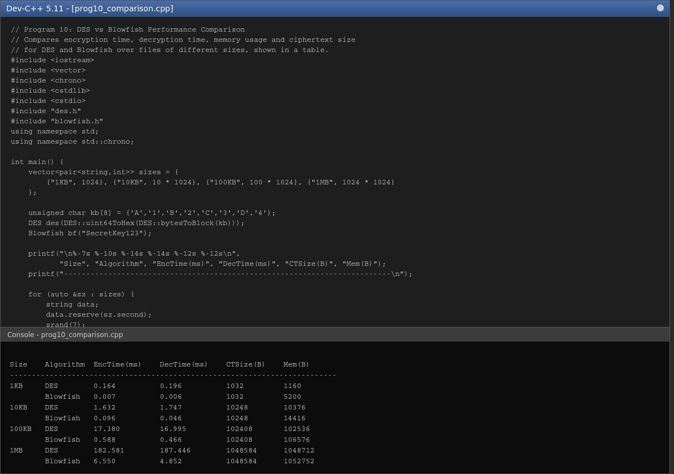

Result
For every file size, Blowfish encrypted and decrypted the data considerably faster than DES (roughly 25-30 times faster in this implementation), while the ciphertext size was identical for both algorithms since both operate on 64-bit blocks. DES showed slightly higher memory overhead per block than Blowfish's per-call overhead, though Blowfish's key schedule itself (P-array + S-boxes) is larger and is set up once before encryption begins.

